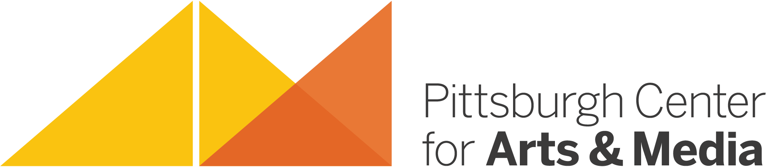

Pittsburgh Center for Arts and Media
ARTIST RESIDENCY PROGRAM

FACT SHEET

- Our partnership with the Pennsylvania Council on the Arts’ Arts in Education Division was formed in 2001.

- The goal of the Artist Residency Program is to offer unique and quality arts services in the form of Artist Residency Projects in southwestern Pennsylvania including Allegheny, Beaver, Greene, and Washington counties.

- Artist Residency Projects are designed to place trained, knowledgeable, and practicing artists into school and community settings where they can share the benefits of the creative process.

- There are approximately fifty Teaching Artists in our program including media artists, dancers, folk artists, musicians, theater artists, visual artists, glass artists, craft artists, interdisciplinary/multi-disciplinary artists, and writers.

- Artist Residency Projects allow traditionally underserved areas and people to experience the value of the arts.

- We typically implement approximately 45-50 projects each program year (September 1 through August 31).

- School-based projects include public, private, parochial, and charter schools serving elementary, middle, and high-school students. Projects can also be designed for the collegiate level.

- Community-based projects may take place with communities, social/human service organizations, libraries, senior citizen facilities, and many other types of regional community and/or cultural organizations.

- Artist Residency Projects are funded by both host sites and with support funding provided by PCA&M through our Partnership with the PA Council on the Arts’ Arts in Education Division.

- Teaching Artists in the Artist Residency Program have daily rates ranging from $200 - $300 for individuals. Group or ensemble rates vary.

- PCA&M’s Artist Residency Program continues to grow, evolve, and expand. It is readily adaptable to a variety of needs, expectations, and situations at all host sites.

