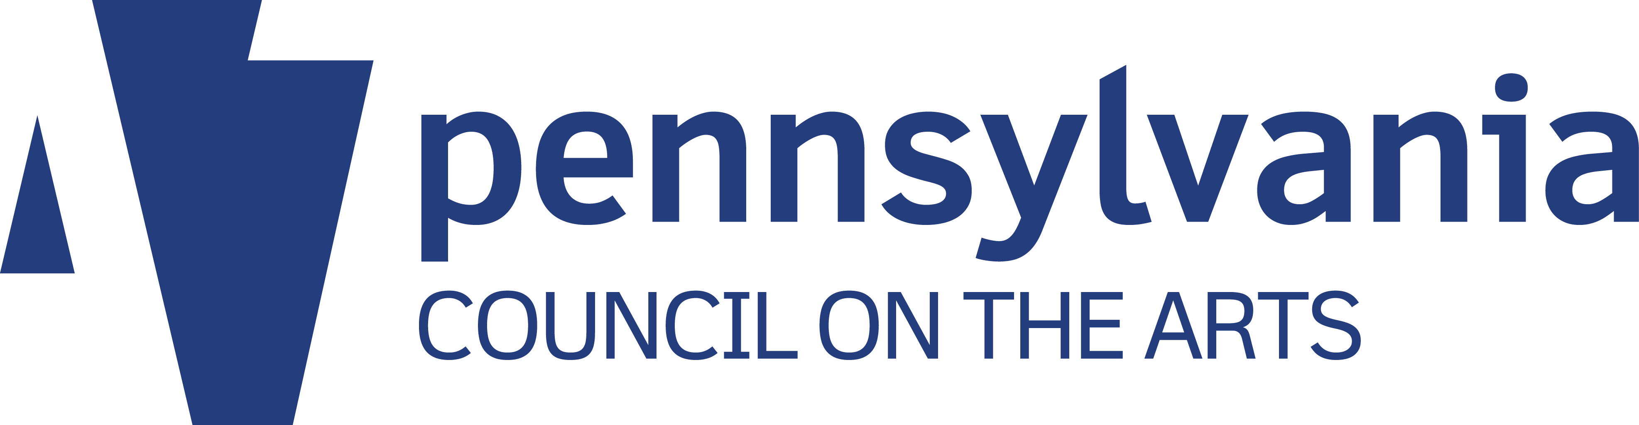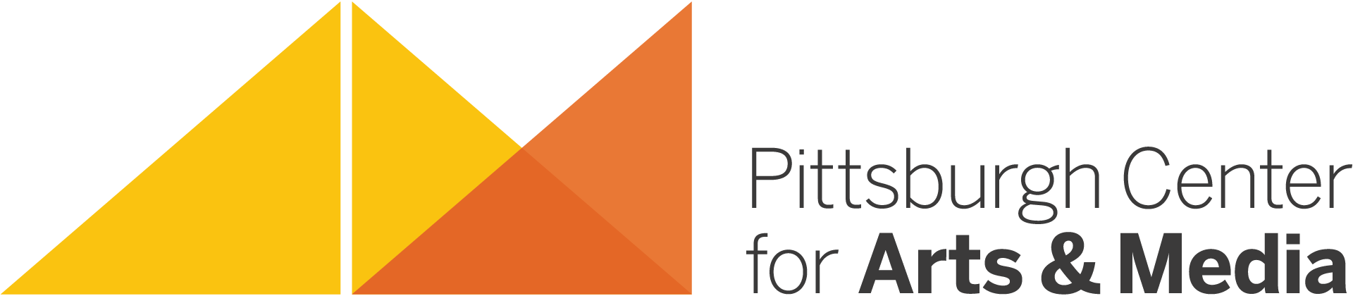
Side A

ARTIST RESIDENCY PROJECT REQUEST FORM

This form must be completed and signed by the host site administrator and project coordinator and submitted to PCA&M in order to be considered for support funding.

Please include all information.

Host Site:______________________________________ District:________________________

Address:____________________________City__________________Zip + 4_______________

Phone:________________________________________ Fax: ___________________________

Site Administrator/Principal:_______________________ Email:__________________________

Site Coordinator:________________________________ Email: _________________________

Title/Grade Level(s) of Site Coordinator:_____________________________________________

Teaching Artist (TA):_____________________________ Art Form:_______________________

Artist Residency Project Budget

Number of Days________ X TA Fee per Day* $ ___________ = TA Cost $____________

10% Project Management Fee on TA Cost = $_____ + TA Cost $_____ = Project Cost $ ____

Project Cost (from above) $_______ - PCA&M Funding Support** ($______) = Site Cost $_______
* TA Fees may range between $200-$350. Please reach out to Mary Brenholts to confirm.)

The host site is responsible for the cost of materials and travel, if applicable.

Source(s) of Host Site funds (e.g., foundation grant, school or district budget, PTA/PTO/PTG, local business, etc): _____________________________________________________________

Artist Residency Project Plan:

To be developed cooperatively with the artist(s), host site, and PCA&M using the Artist Residency Planning Form. Online Evaluation Forms must be submitted upon completion of the residency project.

Artist Residency Project Request Form Submitted By:
_______________________________ _______________________________
Signature of Site Administrator/Principal Date Signature of Site-Coordinator Date

Please return this form to: Mary Brenholts, Director of Artists in Schools & Communities at Pittsburgh Center for Arts & Media
Voice: 412-606-4723 • Email: mbrenholts@pghartsmedia.org

As required by the PA Council on the Arts, PCA&M support funding for Artist Residency Projects is based on the number of project days and there is a 10% project management fee on all projects.
Side B

10 DAY ARTIST RESIDENCY PROJECTS ~ 10% project management fee and 30% PCA&M SUPPORT FUNDING

15 DAY ARTIST RESIDENCY PROJECTS ~ 10% project management fee and 40% PCA&M SUPPORT FUNDING

20 DAY+ ARTIST RESIDENCY PROJECTS ~ 10% project management fee and 50% PCA&M SUPPORT FUNDING

PCA&M support funding increases by 2% increments per each additional day.

