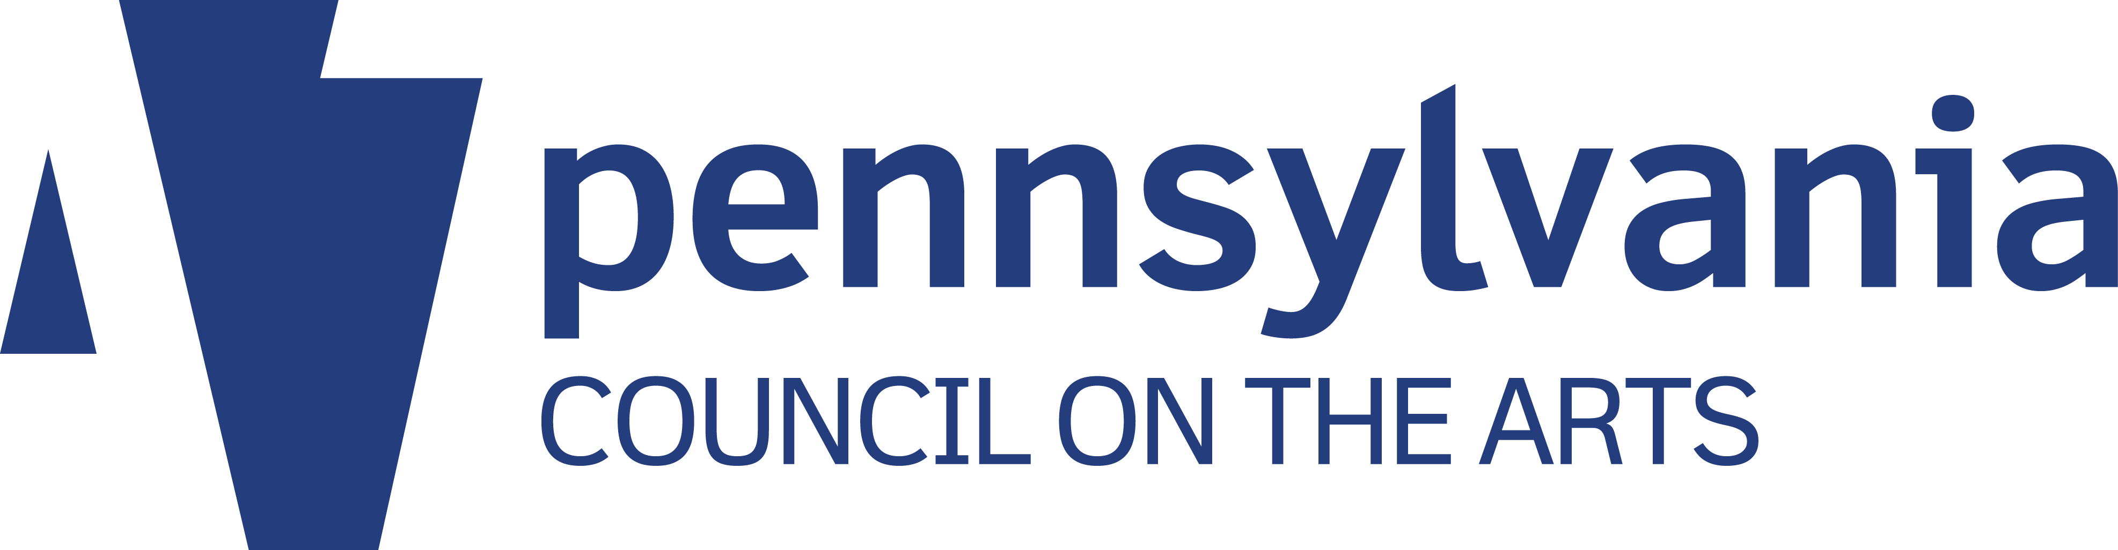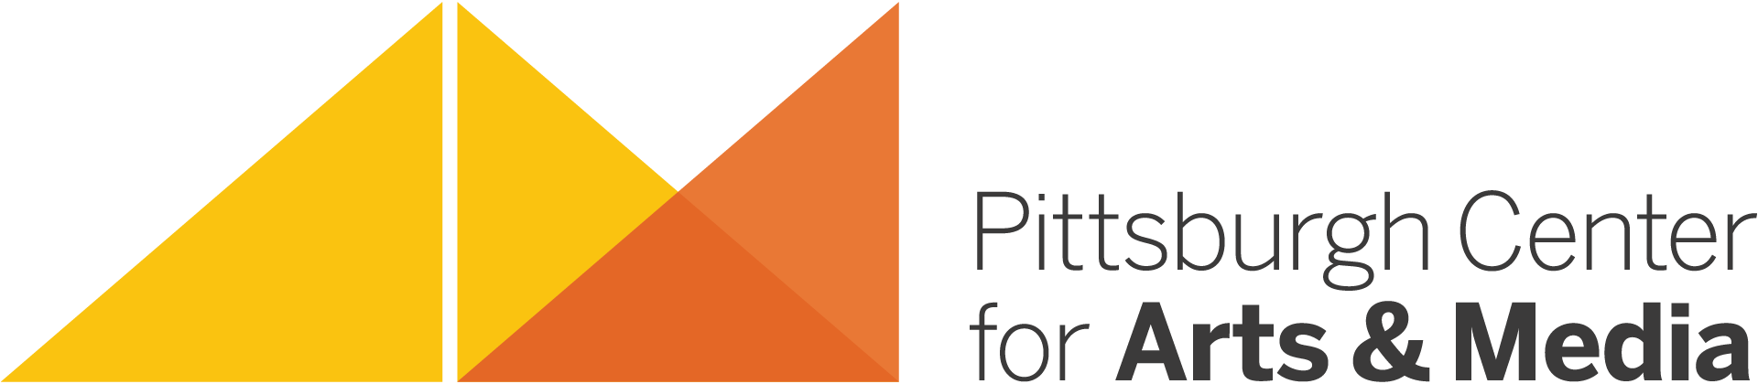

As regional Arts in Education Partner for the Pennsylvania Council on the Arts since 2001, Artists in Schools & Communities at Pittsburgh Center for Arts and Media offers Artist Residency Projects and other vital arts services to schools, communities, community organizations, and nonprofit service agencies working with children and/or adults in Allegheny, Beaver, Greene, and Washington counties through our Artist Residency Program.

Artist Residency Projects have lasting benefits for all participants: students are fully immersed in an art form and see how it connects to life and learning, teachers are exposed to alternative ways of experiencing and sharing the creative process and what it brings to their classrooms, administrators observe the ways in which the arts fully engage students and impact their learning across the curriculum, parents/caregivers recognize how the arts are essential for optimum development of children of all ages, and our dedicated Teaching Artists are artistically reinvigorated through the collaborative creative process. For adults and communities, artmaking provides opportunities for reflecting, sharing thoughts and feelings, learning new ways of communicating ideas, imagining possibilities, and making connections, both internal and external.

As stated in the National Endowment for the Arts’ publication Learning Through the Arts “…the arts help us all better understand and interpret the world around us. The arts improve our ability to think critically and act creatively and offer us the opportunity to communicate our most profound thoughts and deepest feelings. Arts learning ensures that this creative spirit lives on, instilling a love and understanding of the arts to each new generation.” PCA&M and our Resident Artists fully embrace this philosophy and welcome the opportunity to share the skills and rewards of the creative process with enthusiastic and motivated participants.

Through residencies in dance, craft, music, folk arts, theater, media arts, literature, visual and interdisciplinary arts, schools, community organizations, and service agencies can expect to improve themselves and strengthen their communities. By immersing participants in the creative process from beginning to end, and giving them ownership of the process, Resident Artists model the importance of deep focus, rigor, and adaptability in the arts while demonstrating that value not only in creative projects, but throughout participants’ studies, lives, and careers.

The arts are proven to stimulate and enhance student performance in all curriculum areas and to encourage the development of improved self-image and empowerment. The arts provide opportunities for:

- Imagination and creativity to flow
- Communication and problem-solving skills to grow
- Self-directed intrinsic motivation to be engendered
- Teamwork to be encouraged and appreciated
- Diverse thinking to take place
- Individuality to excel
- Positive self-expression to evolve

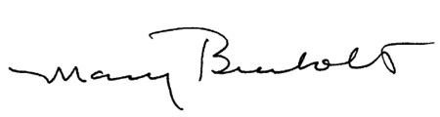

Mary Brenholts
Director, Artists in Schools & Communities

*The Arts in Education Partnership is a program of the Pennsylvania Council on the Arts’ Arts in Education (AIE) Division. The AIE Partnership fosters educational improvement through participation in the creative process in schools and community settings via residencies, projects, and partnerships between schools and/or other educational institutions, artists, and arts organizations. The Arts in Education Partnership is administered in sw PA by Pittsburgh Center for Arts & Media.

