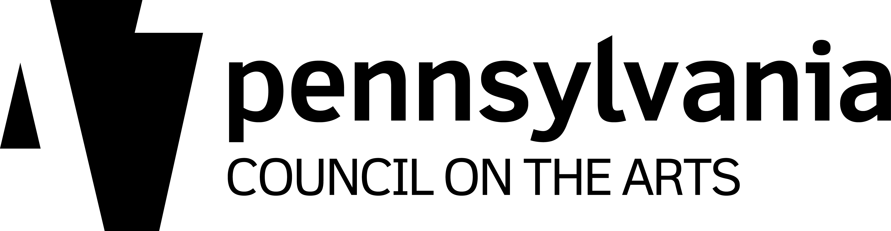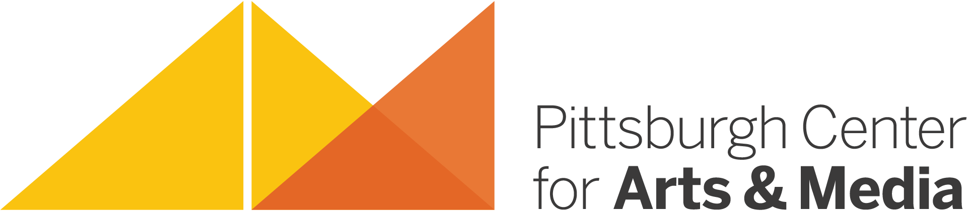
Side A

ARTIST RESIDENCY PROJECT REQUEST FORM

This form must be completed and signed by the host site administrator and project coordinator and submitted to PCA&M in order to be considered for support funding.

Please include all information.

Host Site:______________________________________ District:________________________

Address:____________________________City__________________Zip + 4_______________

Phone:________________________________________ Fax: ___________________________

Site Administrator/Principal:_______________________ Email:__________________________

Site Coordinator:________________________________ Email: _________________________

Title/Grade Level(s) of Site Coordinator:_____________________________________________

Teaching Artist (TA):_____________________________ Art Form:_______________________

Artist Residency Project Budget

Number of Days________ X TA Fee per Day* $ ___________ = TA Cost $____________

10% Admin. Fee on TA Cost = $________ + TA Cost $________ = Project Cost $ ________

Project Cost (from above) $_______ - PCA&M Funding Support** ($______) = Site Cost $_______
*Typical TA Fee per Day is $200
**See back for funding formula

The host site is responsible for the cost of materials and travel, if applicable.

Source(s) of Host Site funds (e.g., foundation grant, school or district budget, PTA/PTO/PTG, local business, etc): _____________________________________________________________

Artist Residency Project Plan:

To be developed cooperatively with the artist(s), host site, and PCA&M using the Artist Residency Planning Form. Online Evaluation Forms must be submitted upon completion of the residency project.

Artist Residency Project Request Form Submitted By:
_______________________________ _______________________________
Signature of Site Administrator/Principal Date Signature of Site-Coordinator Date

Please return this form to: Mary Brenholts, Pittsburgh Center for Arts & Media, 1047 Shady Avenue, Pittsburgh, PA 15232
Voice: 412-361-0455, ext 404 • Email: mbrenholts@pfpca.org

As required by the PA Council on the Arts, PCA&M support funding for Artist Residency Projects is based on the number of project days and there is a 10% administration fee on all projects.
Side B

Examples:

10 DAY ARTIST RESIDENCY PROJECTS ~ 10% admin and 30% PCA&M SUPPORT FUNDING

10 days X $200 TA Fee per Day = $2,000

10% Administration Fee = $200

$2,200 Project Cost

PCA&M 30% Funding Support = ($600)

Host Site = $1,400 + $200 Administration Fee

Total Site Cost = $1,600 (plus materials)

15 DAY ARTIST RESIDENCY PROJECTS ~ 10% admin and 40% PCA&M SUPPORT FUNDING

15 days X $200 TA Fee per Day = $3,000

10% Administration Fee = $300

$3,300 Project Cost

PCA&M 40% funding support = ($1,200)

Host Site = $1,800 + $300 Administration Fee

Total Site Cost = $2,100 (plus materials)

20 DAY ARTIST RESIDENCY PROJECTS ~ 10% admin and 50% PCA&M SUPPORT FUNDING

20 days X $200 TA Fee per Day = $4,000

10% Administration Fee = $400

$4,400 Project Cost

PCA&M 50% Funding Support = ($2,000)

Host Site = $2,000 + $400 Administration Fee

Total Site Cost = $2,400 (plus materials)

