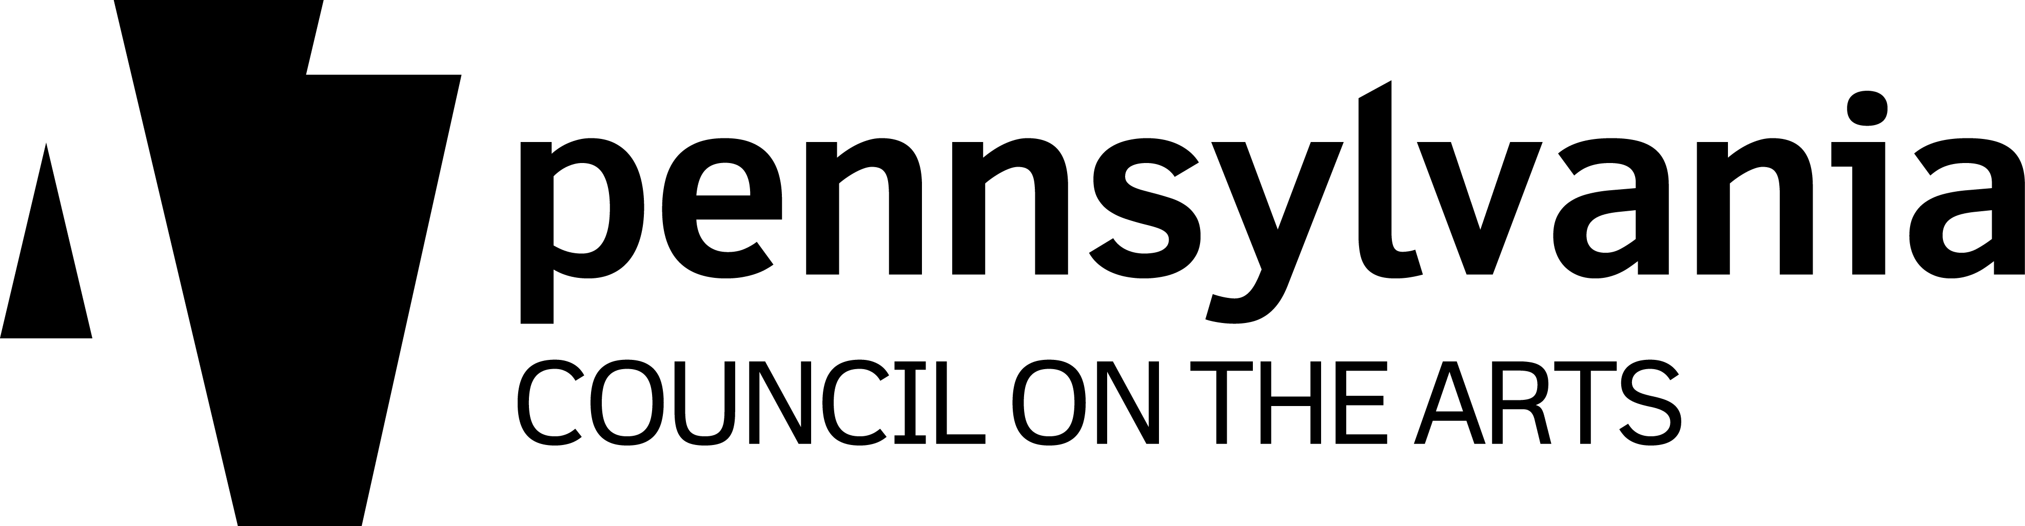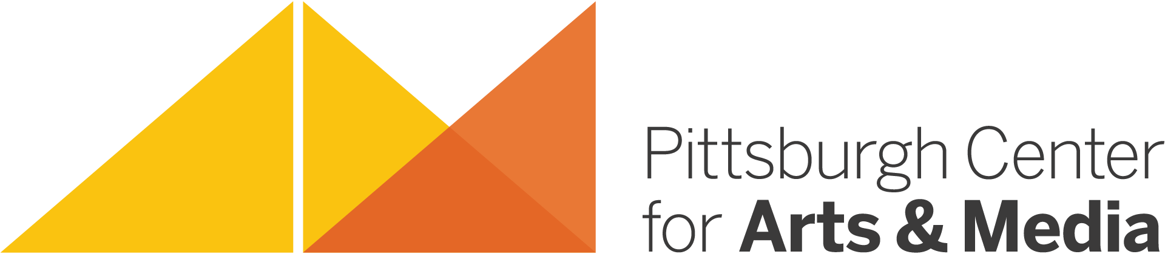

Pittsburgh Center for Arts & Media
Artist Residency Program
in partnership with the
PA Council on the Arts

ARTIST RESIDENCY PROJECT CHECKLIST

Before a Project Begins

Artist Residency Request Form Completed, Signed, and Submitted

Planning Meeting Scheduled and Held

Planning Forms (including residency dates/times) Discussed, Completed, and Submitted

The above items MUST be completed and submitted before an Artist Residency Project begins.

__________________________________________________________________________________________

During a Project

Photo/Media Release Forms Distributed, Signed, and Submitted

5-10 Captioned Photos (students~with photo releases~ hands working, finished products, etc.) Submitted

Project Information Shared with Stakeholders:

- Parents
- School Administrators
- PTA Members
- Community Members
- Press Contacts
- Politicians (state, local, or regional)

Invite Stakeholders to visit the Artist Residency Project as it’s taking place or to attend any celebrations, receptions, presentations, or exhibitions of the work created during the Artist Residency Project.

__________________________________________________________________________________________

After a Project Concludes

On-line Project Evaluations Completed and Submitted:

- Resident Artist
- Teacher/Site Coordinator
- Administrator/Principal

