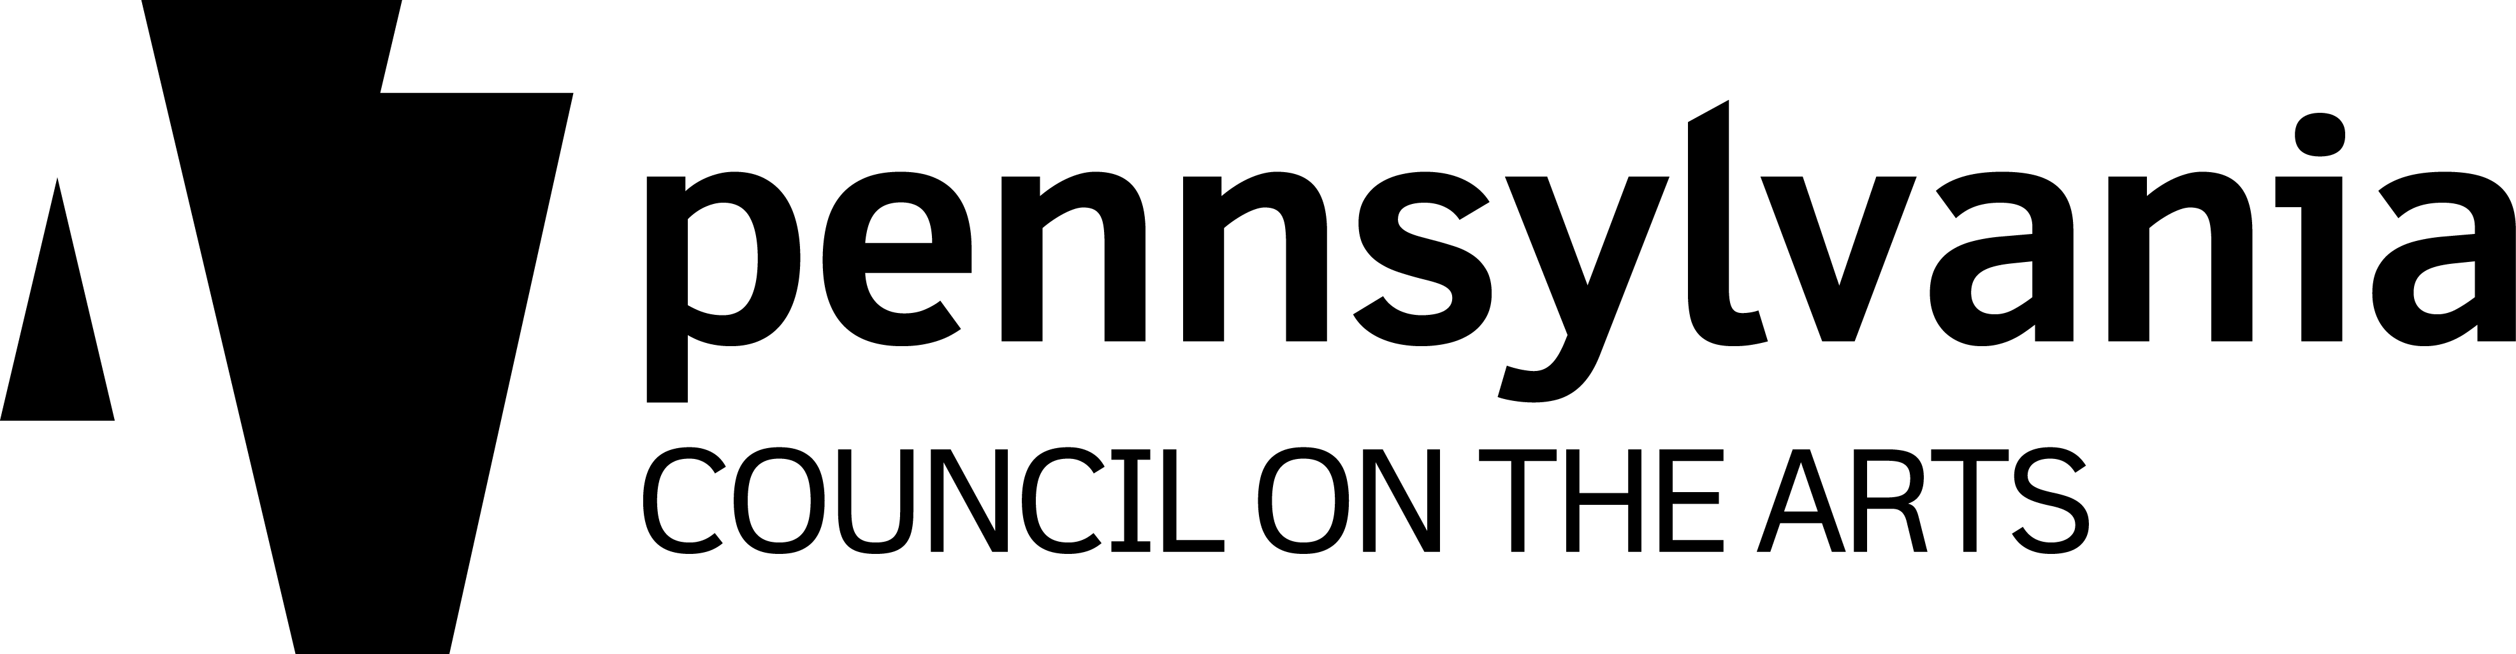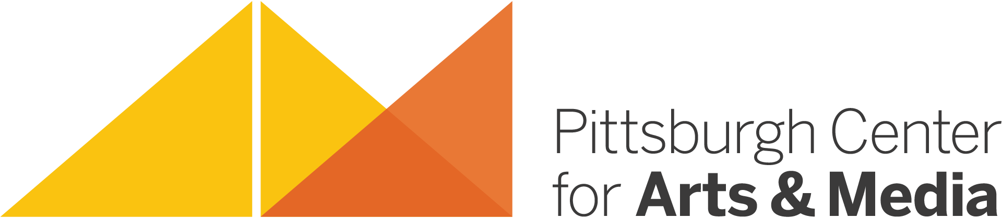

HOW TO INITIATE AND REQUEST
an
ARTIST RESIDENCY PROJECT AT YOUR SITE!

- Read through the online list of Resident Artists to get an idea of the various art forms, styles, and philosophies of our talented and dedicated Resident Artists.

- Look at the “fact sheet” and supporting materials included in this packet to get a sense of the way the program works most effectively. Jot down any questions you might like to ask.

- Contact the Resident Artist(s) directly to see how you can work together or contact Mary Brenholts to get suggestions on which artist(s) would be the best match at your site.

You should make contact with the Resident Artist before a Request Form is submitted. Confirm their daily rate and the number of days needed to make a residency work best for all participants.

- Submit the Artist Residency Request Form as soon as possible to secure funding for your project. Requests are accepted on a rolling basis. Funding amounts and availability are determined based upon a variety of factors.

- Make sure matching funds from your site are made available and kept accessible for the Artist Residency Project. PCA&M contracts with and pays the Resident Artist in full and invoices the host site for their portion of the fee.

Consider working with a local business or industry to help fund your project!

- Once your Artist Residency Project has been confirmed, schedule a Planning Meeting with the artist and PCA&M to develop your Residency Plan. Set project dates with the artist as soon as possible; schedules fill quickly!

Note: Our Resident Artists are Independent Contractors and therefore are responsible for their own schedules and scheduling.

