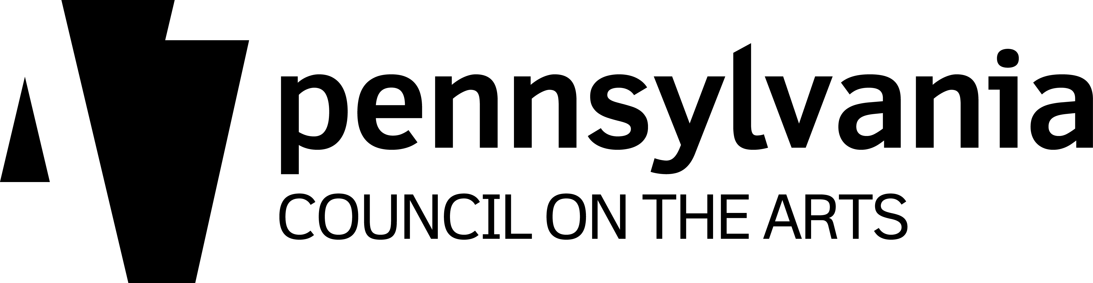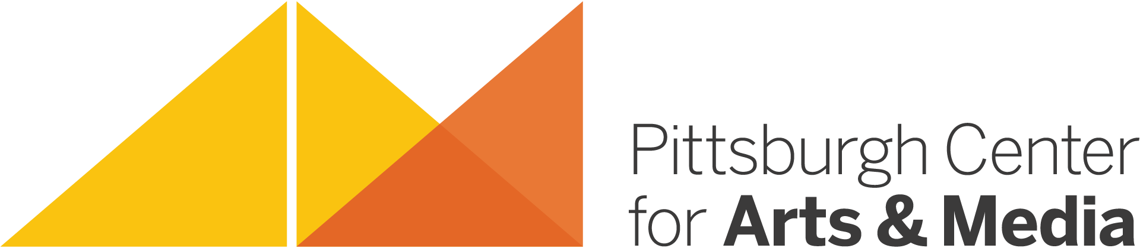

Frequently Asked Questions

1. What is an Artist Residency Project?
Artist Residency Projects are designed to place professional artists into school and community settings where they can share the myriad benefits of their creative processes. Each Residency Project is a custom-designed collaboration between the host site and the Resident Artist. PCA&M’s Artist Residency Program was founded in 2001 through our partnership with the Pennsylvania Council on the Arts‘ Arts in Education Division.

2. Who is eligible for an Artist Residency Project?
Schools, nonprofit agencies, and community organizations working with both children and adults in Allegheny, Beaver, Greene, and Washington Counties are eligible for an Artist Residency Project. School-based residencies include public, private, parochial, and charter schools serving elementary, middle, and high-school students. Residencies can also be designed at the collegiate level. Community-based residencies in social and human service agencies include social rehabilitation sites for adults, special needs children in an inclusion-oriented program, senior citizen facilities, as well as projects at many other types of community and cultural organizations.

3. What are the benefits of an Artist Residency Project?
Studies have shown a significant correlation between arts education and skills development, resulting in improved levels of achievement. Skills developed through the arts are recognized as being essential elements for success in today’s society. These skills, as noted by Robert Root-Bernstein, Professor of Physiology at Michigan State University, include the ability to:
- observe acutely
- think spatially and kinesthetically
- identify the essential components of a complex whole
- recognize and invent patterns
- gain empathy with objects of study
- synthesize and communicate the results of one’s thinking, visually, verbally, or mathematically.
Teachers and artists working together gain skills and insights from each other that translate into improved learning for current students as well as future learners.

4. How many days constitute and Artist Residency Project?
Residencies can last anywhere from 10 to 180 days for individual artists and groups/ensembles. The days don’t need to be consecutive. A Resident Artist can work at a site one day a week for eighteen weeks, twice a week for five weeks or twice a month for the whole school year. Artists may work directly with core group participants up to four hours per day. If pre-determined during the planning meeting, they may also work with or present to other classrooms or conduct workshops for teachers, administrators, and/or parents.

5. What is a core group?
An Artist Residency Project is designed as an in-depth medium-specific experience for up to three core groups of students, not to exceed 30 students per group. The program is described as allowing a full embrace for a smaller number of participants rather than providing just a handshake for every student in the school. The artist may be introduced at an assembly, may do a whole school performance or slide show, may visit classrooms to talk with other students, and may provide workshops for teachers to take specific techniques and creative ideas back to their classrooms. Please welcome the Resident Artist to your site with the idea of positively impacting everyone in the building, but giving the core group students and teachers a fuller, richer, in-depth experience.

6. What kinds of artists are in the Artist Residency Program?
We currently have approximately 40-45 Resident Artists in our program, including media artists, dancers, folk artists, inter- and multi-disciplinary artists, fiber artists, jewelers, musicians, visual artists, craftsmen, clown artists, writers, and more! These artists are professionals who are exhibiting, performing, and publishing regularly. If you open up a regional, or sometimes a national, newspaper, you are likely to see positive reviews of their works each week. Part of the skill set of a Resident Artist is his/her ability to communicate both the creative process and the techniques of his/her medium. Artist applying to the program undergo an independent panel review process. Qualifying artists are chosen based on the quality of their artwork, their ability to articulate their artform and residency project plans to an independent review panel of artists, educators, and administrators, and on their proven ability to fully implement a successful residency plan. The panel sends its recommendations to the Pennsylvania Council on the Arts, which makes the final decision regarding approval. Once approved, the Resident Artists are placed on our roster but are not employees of Pittsburgh Center for Arts & Media. They maintain their own studio spaces and often work for other non-profit arts organizations as well as PCA&M.

7. How do the Resident Artists get paid?
Artist Residencies are funded by the host site with support funding provided by PCA&M through our partnership with the PA Council on the Arts’ Arts in Education Division. PCA&M contracts with and pays the artist in full and invoices the host site for its match.

8. Is it difficult/competitive to receive matching funds for an Artist Residency Project?
It is not at all difficult, although artists’ schedules fill up quickly so make your requests in a timely fashion. The program is designed to operate on an on-demand basis, but funding is limited.

9. How much will this cost?
Most individual Resident Artists are paid $200 per day. Some artists have slightly higher fees. Companies’ and ensembles’ daily rates vary depending on the size of the group. There is a sliding rate scale for host sites based on the number of days of a residency project as required by the PA Council on the Arts. This information can be found on Side B of the Artist Residency Request Form. The host site is solely responsible for the cost of materials and for any compensation to the artist associated with travel expenses. Resident Artists excel at making the cost of materials for their projects affordable to the host sites.

10. How will the Artist Residency Project fit in with existing programs/curriculum?
Since the Resident Artist, representatives from the host site, and PCA&M plan the residency project together, much care is taken to address Pennsylvania’s Arts & Humanities Standards in all art forms and to clearly articulate the goal of having the Resident Artist at the site. Artists and teachers regularly communicate regarding the intent of the project and how to tie the art form into a specific program and/or extend it throughout the curriculum. Often it is not the Arts Educators who are working with the Resident Artist but, rather, the Classroom Teacher who recognizes how an artform brought to life by a practicing artist can fully illuminate a concept for students.

11. OK, I’ve decided that I want to participate in this program! What are the next steps?
Step 1: Think about specific areas of your curriculum or program that could benefit by having a Resident Artist with whom to work. Review the online Artist Residency Directory to see which artist(s) might provide insight into or illumination of that area. You may call Mary Brenholts, Director of Artists in Schools & Communities at 412-361-0455, ex 404 to discuss which artist(s) might be most suitable to meet the needs of your host site. Read through the supporting materials included in this packet in order to get a better understanding if how the program works and how it is intended to improve host sites, now and into the future.

Step 2: Contact the Resident Artist(s) to discuss your ideas. Check on availability, daily rate, potential cost of materials, and other items particular to each artist/artform.

Step 3: Complete the enclosed Artist Residency Request Form making sure to provide us with as many details as possible. If you are uncertain at this point about the source or confirmation of your matching funds simply write “pending” or “awaiting approval.” You may have funds provided by a school budget, district budget, a PTA, PTO, or PTG, or from a foundation or local business. Some sites hold fundraisers in their communities. The request form is not a binding document, it simply allows us to determine demand for the program and how to best allocate our funds. If you are unsure of how to complete the budget section, call us for assistance. Make certain to get signatures from principals or other appropriate administrators. Submit your request form as soon as possible to ensure having a good chance to receive matching funds.

Step 4: Meet with the Resident Artist(s) to review and complete the Artist Residency Planning Form. Use the questions as tools to help develop a comprehensive plan designed to have lasting impact. Set dates with the Resident Artist(s) as soon as possible! Submit your planning form upon completion.

Step 5: Once we have received your Artist Residency Request Form and we receive our funding confirmation from the Pennsylvania Council on the Arts, we will generate the paperwork designed to keep the process moving forward cleanly and clearly. We are just a phone call (412-361-0873, ext 404) or e-mail (mbrenholts@pfpca.org) away at all times and love hearing from potential host sites to answer questions and/or share ideas.

