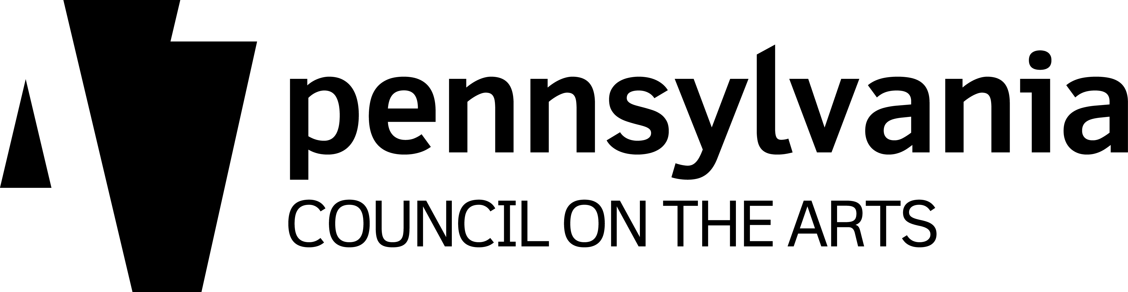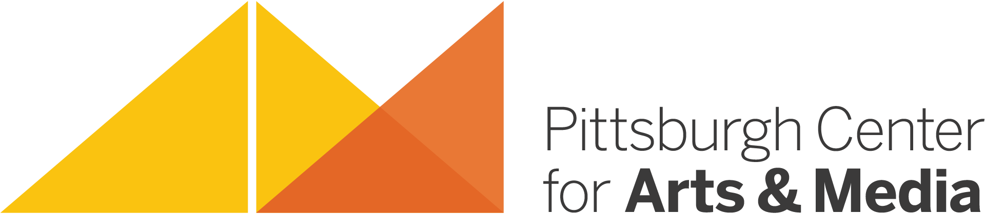

Pittsburgh Center for Arts & Media
ARTIST RESIDENCY PROGRAM

FACT SHEET

- Our partnership with the Pennsylvania Council on the Arts‘ Arts in Education Division was formed in 2001.

- The mission of the Artist Residency Program is to offer unique and quality arts services in the form of Artist Residency Projects in in southwestern Pennsylvania including Allegheny, Beaver, Greene, and Washington counties.

- Artist Residency Projects are designed to place trained, knowledgeable, and practicing artists into school and community settings where they can share the benefits of the creative process.

- We have over 40 Resident Artists in our program including media artists, dancers, folk artists, musicians, visual artists, glass artists, craft artists, and writers.

- Artist Residency Projects allow traditionally underserved areas to experience the value of the arts.

- We typically receive approximately 75 inquiries and requests from host sites per program year (September 1 through August 31) and implement approximately 40-50 projects.

- School-based projects include public, private, parochial, and charter schools serving elementary, middle, and high-school students. Projects can also be designed for the collegiate level.

- Community-based projects may take place at social rehabilitation sites for adults, special needs children in an inclusion-oriented program, senior citizen facilities, and at many other types of regional community and cultural organizations.

- Artist Residency Projects are funded by both host sites and with matching funds provided by PCA&M through our Partnership with the PA Council on the Arts’ Arts in Education Division.

- Resident Artists in the Program have a minimum daily rate of $200 for individuals. Group or ensemble rates vary.

- PCA&M’s Artist Residency Program continues to grow and evolve and is readily adaptable to a variety of needs, expectations, and situations at all host sites.

