***Program***

**Introductions and Remarks**

Dr. Pat Sheahan ~ Emcee

Mary Brenholts ~ Director, Artists in Schools & Communities at PF/PCA

Jamie Dunlap ~ Director, Arts in Education, PA Council on the Arts

Lisa Alexander, Romella Kitchens, Don Wentworth, Sarah Leavens,

Emily Stedge ~ Judges/Prompter

**Round 1 Recitations**

Angela Miller *“The Ocean”* by Nathaniel Hawthorne

Mya Swain *“Domestic Situation”* by Ernest Hilbert

Genesis Analise Gore *“The Negro Speaks of Rivers”* by Langston Hughes

Ceresa Morsaint *“The World Is Too Much With Us”*

by William Wordsworth

Zoe Koutavas *“Beautiful Wreckage*” by W.D. Ehrhart

Emma Steckline *“Beautiful Wreckage*” by W.D. Ehrhart

Zachary Esch *“Acquainted with the Night”* by Robert Frost

Sahana Rao *“I Am Offering this Poem”* by Jimmy Santiago Baca

**Round 2 Recitations**

Angela Miller *“Self-Portrait”* by Chase Twichell

Mya Swain *“Awaking in New York”* by Maya Angelou

Genesis Analise Gore *“’Hope’ is the thing with feathers”* by Emily Dickinson

Ceresa Morsaint *“Through a Glass Eye, Lightly*” by Carolyn Kizer

Zoe Koutavas *“Holy Sonnets: Death, be not proud”* by John Donne

Emma Steckline *“The Charge of the Light Brigade”*

by Alfred, Lord Tennyson

Zachary Esch “*Eating Poetry”* by Mark Strand

Sahana Rao *“I Wandered Lonely as a Cloud”*

by William Wordsworth

**Round 3 Recitations**

Angela Miller *“A Fixed Idea”* by Amy Lowell

Mya Swain *“April Love”* by Ernest Dowson

Genesis Analise Gore *“I, Too”* by Langston Hughes

Ceresa Morsaint *“Winter”* by Marie Ponsot

Zoe Koutavas *“Vain and Careless”* by Robert Graves

Emma Steckline “*Planetarium”* by Adrienne Rich

Zachary Esch *“It sifts from Leaden Sieves”* by Emily Dickinson

Sahana Rao *“More Lies”* by Karin Gottshall

***School Finalists***

**Angela Miller** is currently a senior at Baldwin High School. This is her first time competing in the Poetry Out Loud competition. She is a devout lover of poetry, English Breakfast tea, and cats. She can usually be found aimlessly roaming around Target, goofing off with friends, or working at one of her various jobs.

**Mya Swain** – I sat here for over half an hour trying to write this, yet somehow managed to get it done on time. I guess that’s something interesting about myself. I also sort of entered this contest on a whim. I’m quite happy I did so. Also, I can cook a mean quiche.

**Genesis Analise Gore** is a senior Literary Arts major at Westinghouse Arts Academy Charter School. She is the Assistant Stage Manager for this year’s musical and an ambassador for the school, representing them at many events. When not at school, she works part time at a local pizza shop and writes poetry. She would like to thank her mother, her teachers, and her brothers. She will attend college for business in the fall.

**Ceresa Morsaint** is a sophomore and Writing & Publishing major at Lincoln Park Performing Arts Charter School. She has participated in many writing competitions and workshops, such as: Writing Away The Stigma (for teens) with Lee Gutkind and reading her own poetry to a Holocaust survivor. She hopes to become a sign language interpretor, Spanish teacher, or English professor and write creative nonfiction about her life later on. She believes in keeping the art of poetry alive, because the death of poetry is the beginning of the end for all creative literature.

**Zoe Koutavas –** I am a versatile nerd. As Treasurer of the Underwater Robotics Team, Technology Student Association, and Speech and Debate Club, I decide who gets paid. I enjoy technology and public speaking and one day hope to become an engineer. Which is still up in the air, but I know I want to help make a better world.

**Emma Steckline** is a junior at Pittsburgh CAPA 6-12, where she is in the Literary Arts Program. She won CMU 19th Annual Martin Luther King, Jr. Writing Awards for High School Prose in 2018. She was in Pittsburgh CAPA 6-12’s Gene Kelly Award winning production of “Les Misérables. She loves her dog, her guinea pig, and her amazing friends. She is thrilled to be competing in the regional Poetry Out Loud competition.

**Zachary Esch** is a junior at Seton LaSalle Catholic High School. He plays baritone saxophone in his school’s marching band, concert band, and jazz ensemble, and recently represented his school in the PMEA District Band. Zachary is also the junior leader of his school’s student-run award-winning a capella group, the Trebels. Zachary also participates in spring musical, fall drama, Rebels for Life, Guitar Rebels, choir, Boy Scouts, and plays varsity soccer.

**Sahana Rao –** Hello! I am a freshman at Montour High School. I am involved in various clubs such as Law Team, Sign Language, Model UN, Global Leadership, Girl Up, Lost Arts, and a few others, including Poetry Out Loud. I love to read, write, sing, dance, draw, play piano, and write songs. I think of poetry slam as an outlet, a chance to express myself, and a great learning experience to help me get over my fear of performing in front of a crowd.

***Judges, Prompter, Emcee, and Musician***

**Lisa Alexander’s** poems have appeared in various journals including *Tupelo Quarterly*, *2 Bridges Review*, *Pittsburgh Poetry Review*, *The Burnside Review*, *BLOOM*, and *5 AM* among others. She holds an MFA in poetry from Drew University, and is a member of the Madwomen in the Attic writing workshops in Pittsburgh, PA. She has been a sound engineer for *Prosody,*the long-running radio show and podcast that features the work of national writers, for many years. She also co-curates the Laser Cat reading series and the MadFridays reading series.

**Romella Kitchens** is a Pittsburgh native, a graduate of the University Of Pittsburgh with three Master's Degrees in Education. She has written poetry for over fifty years, has taught poetry to children and adults, presented poetry and orated poetry on stage, television and more. She has 4 published chapbooks and most recently has read poetry for Glorious Women Poets of Pittsburgh and the Hemingway's Cafe Summer Reading Series. She will read for the Staghorn Cafe Poetry Series in April of this year.

**Don Wentworth** is a Pittsburgh-based poet and editor whose work reflects his interest in the revelatory nature of brief, haiku-like moments in everyday life. His poetry has appeared in *Modern Haiku, bear creek haiku, frogpond,* and *Rolling Stone*, as well as a number of anthologies. He is the author of four full-length collections: *Past All Traps*(2011), *Yield to the Willow* (2014), *With a Deepening Presence*(2016), published by Six Gallery, and *Touching the Now* (Skylark, 2018), a tan-renga sequence co-authored with the British poet, Joy McCall. His poem “hiding” was selected as one of “100 Notable Haiku” of 2013 by Modern Haiku Press. For the last 29 years, he has edited the small press magazine, *Lilliput Review*, the focus of which is the brief poem, 10 lines or less.

**Sarah Leavens** is writer, teacher, and artist residing in Pittsburgh, PA. A Lecturer in English at the University of Pittsburgh, she also works as a teaching artist specializing in creative writing, bookbinding, visual art, and intersections thereof. Her poetry has appeared in *Pretty Owl Poetry*, *LUNCH*, *The Diverse Arts Press*, *Corium*, and *So to Speak*, among other places.Leavens received an MFA in poetry and nonfiction from Chatham University in 2012.

**Emily Stedge** studied English Writing at the University of Pittsburgh. She currently works in the Education Department at Pittsburgh Filmmakers / Pittsburgh Center for the Arts. Currently, she is working on her first novel and a collection of short stories.

**Dr. Pat Sheahan**, a Duquesne University Professor for the School of Education, finds inspiration every day in the ways that Pittsburgh nurtures emerging artists through dance, music, writing, theatre, and the visual arts. “Pittsburgh is the only city where an artist can afford to live on more than bread alone!” says Sheahan, noting that this explains in part the wealth of artistic talent found in the region. And because Pittsburgh nurtures its artists, she says, they can in turn nurture a love of art in the next generation, a big plus for the region.

**Jeff Berman** is a multi-instrumentalist, improvising artist, composer, and educator whose work crosses the borders of musical inspiration. A native of NYC now living in Pittsburgh, his evocative and ambitious performance concept on vibraphone, percussion, and mountain dulcimer has allowed him to collaborate, across stylistic boundaries, with a diverse group of artists from across the planet.

Josef Woodard has described his music as “a worldly folk-jazz”, Jazziz has written “…hypnotic vibes work…Berman not only plays vibes, he sounds like he created the instrument”, and Bill Milkowski has called Jeff’s writing “…hauntingly beautiful…”. He has performed internationally both as a solo artist and as a member of various ensembles. Some of the artists he has performed, recorded and collaborated with include Andy Statman, Paul Bley, Linda Thompson, Robert Een, Susan Mckeown, Andy Irvine, Tibetan singer Pasang Dolma, and AppalAsia, to name just a few.

*This program is supported in part by the Arts in Education Partnership of the Pennsylvania Council on the Arts, a state agency funded by the Commonwealth of Pennsylvania and the National Endowment for the Arts, a federal agency. The Arts in Education Partner serving Allegheny, Beaver, Greene, and Washington counties is Pittsburgh Filmmakers/Pittsburgh Center for the Arts.*

**The National Endowment for the Arts**

**and**

**The Poetry Foundation**

**present**

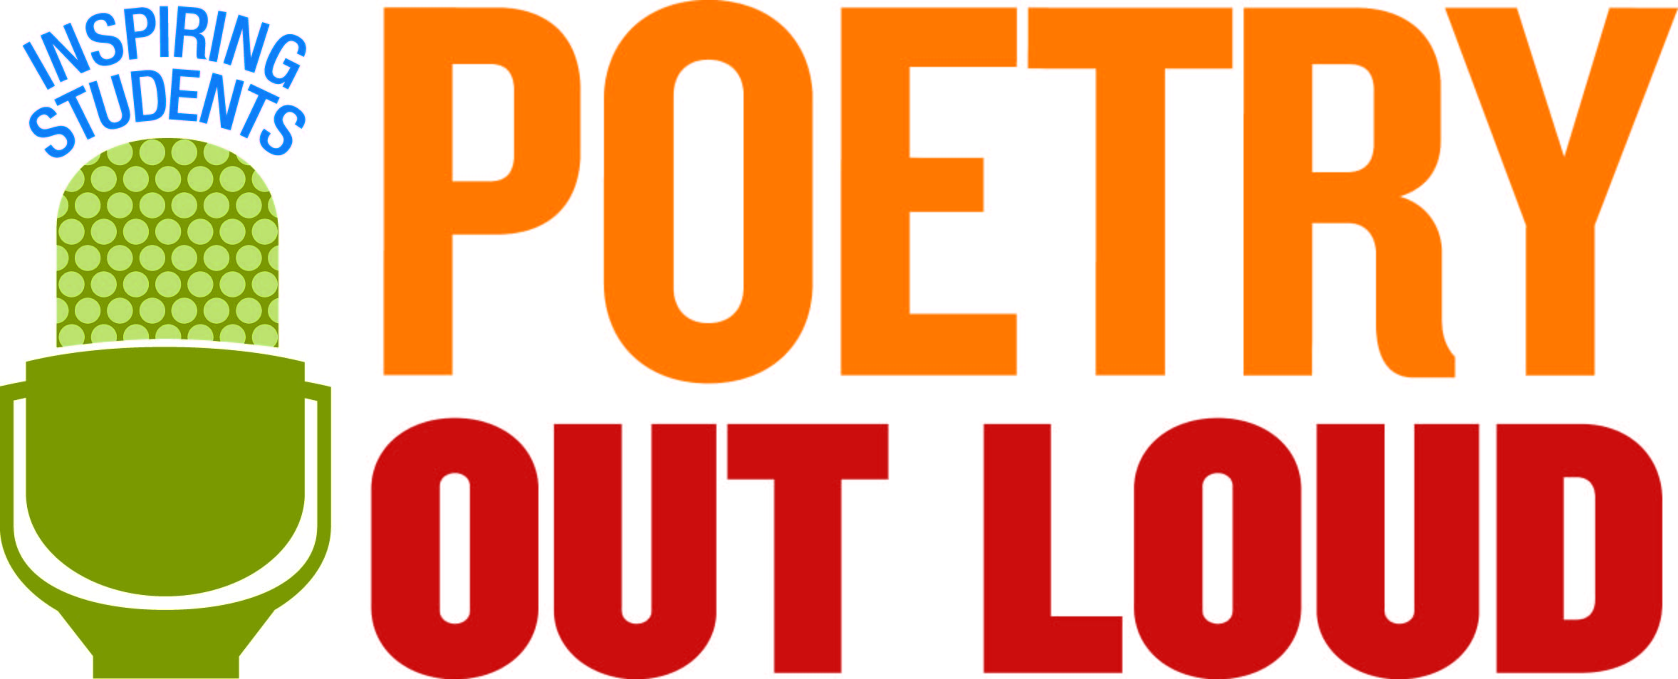

**Regional Competition**

**held by**

**Pittsburgh Filmmakers/Pittsburgh Center for the Arts**

***featuring***

**Angela Miller ~ Baldwin High School**

**Mya Swain ~ Urban Pathways 6-12 Charter School**

**Genesis Analise Gore ~ Westinghouse Arts Academy Charter School**

**Ceresa Morsaint ~ Lincoln Park Performing Arts Charter School**

**Zoe Koutavas ~ South Fayette High School**

**Emma Steckline ~ Pittsburgh CAPA 6-12**

**Zachary Esch ~ Seton LaSalle Catholic High School**

**Sahana Rao ~ Montour High School**

**Saturday, February 2, 2019**

**10:00 a.m.**

**Pittsburgh Filmmakers/Pittsburgh Center for the Arts**

**Regent Square Theater**

